Használt mesterséges intelligencia alkalmazás: Google gemini
- Prompt:
- A majestic creature stands atop a misty mountain peak at sunrise, its huge wings glowing with golden light. Its body is a fusion of lion, eagle, and dragon features, with shimmering scales and flowing fur that moves gently in the wind.
- 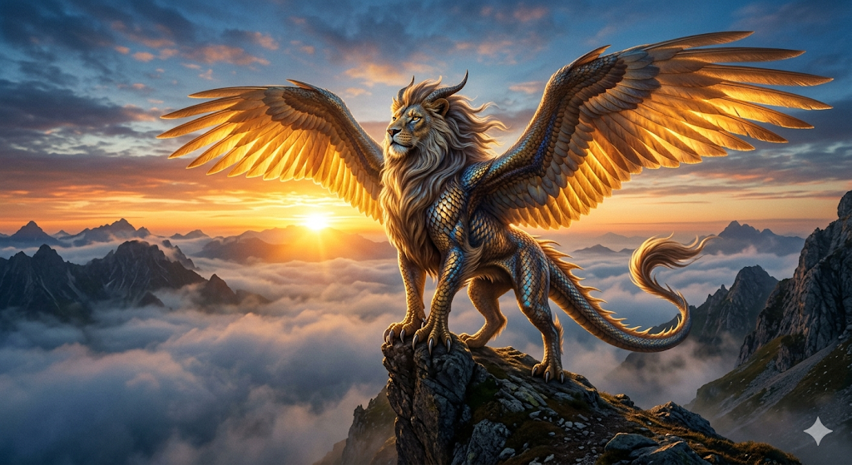

- Prompt:
- god rays through clouds, subtle golden dust particles in the air, light mist around the creature’s feet, lower camera angle
- 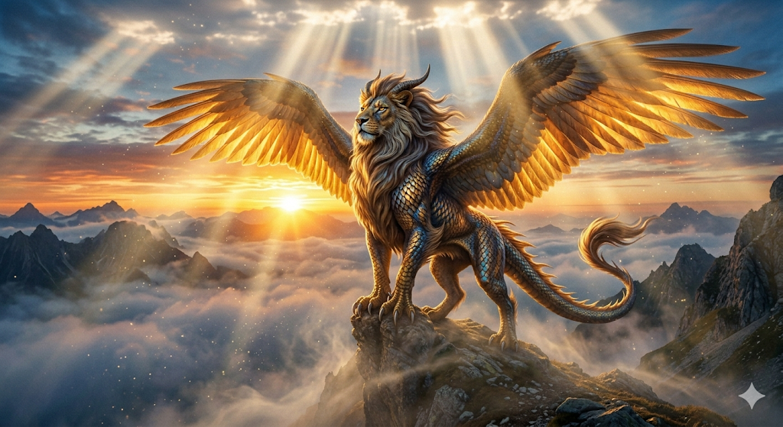

Végső alkotás:


